Four Temples in Eastern Hemisphere

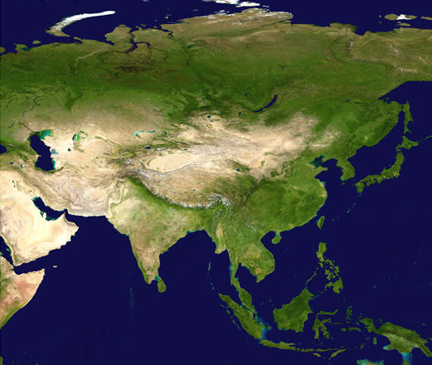
Temple of Vulcan
Southern Vietnam
Temple of Mercury
Northeastern India & Nepal
Temple of Jupiter
Xi’an, China
Temple of Neptune
Olkhon Island,
Lake Baikal, Siberia

