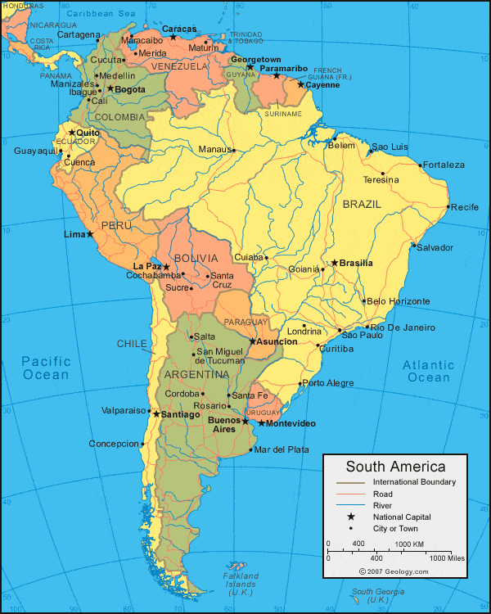
Two Temples in South America
Tenth Temple
of Uranus
Fifth Temple
of Uranus

Temple of Uranus: Manaus, Brazil ● Tenth Temple: Cordoba, Argentina

