Lu-See-A with 16 Crystals in her Eyes
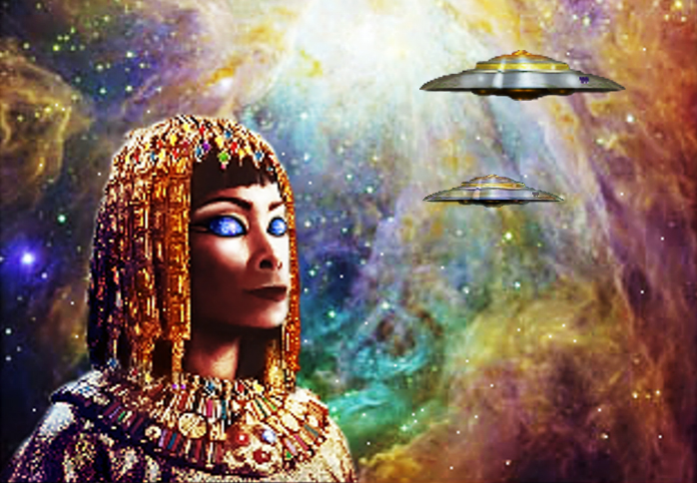
By Hartmut Jager

