Africa Mokili Mobimba: The Triumph of the Congo

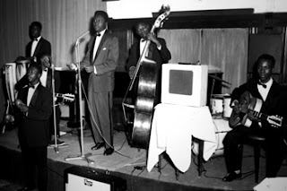

Awa ngai na vandi motema mobongi te oh
Okomo omonisa ngai bambanda na miso (2x)
Iya la baneri African Jazz la compagne
Nakei mobembo sima na nga banzaka
Kokanisa te cherie nakozongela yo

Na Kinshasa na Matadi pe na Boma pe mayombe
Mayi mongala ekwatele,kivu maniema,kisangani
pena brazza,puente nuare kamerun,ghana guinee
pe na mali pe na poto amerika mokili mobimba
balingi babina miziki ya afrika...

The following post began as an email sent to two Egyptian-American friends about Congolese music, perhaps the best genre in all of the vast continent of Africa's forms of music. Here is what I sent them:
"Africa Mokili Mobimba" by African Jazz, and composed by Mwamba Dechaud, is one of the best songs I have ever heard. Recorded in Belgium by the Congolese rumba band after Congolese independence in 1960, the band also features a white jazz drummer from Europe. The song is about African Jazz's music playing across Africa and the world, which, coincidentally, it did. Their song "Independence Cha Cha" became an anthem for African independence and this song in particular was a hit. The lyrics refer to various African countries and even America as places where their music can be heard, although, in 1961, nobody in the US was really listening to Congolese music.
Part of the reason I love it is because of the inherent Pan-Africanist, pro-black ethos pouring out of this song. The way they sing Africa in the chorus makes that quite clear, as well as lyrics alluding to several regions and cities of the Congo, such as Matadi, Kinshasa, Kivu, Brazzaville in the Republic of Congo, and other African nations such as Ghana and Mali. In addition, the band copies traditional praise song by naming the bandmates in the lyrics, thereby keeping alive local traditions and music. Furthermore, the band African Jazz, like most Congolese groups from this period, were creating music partly based on Afro-Caribbean, especially Cuban, music. Thus, this music is a product of the Black Atlantic world, of the Atlantic slave trade, and European imperialism. Music of the Caribbean, of African origin, travels back to its source in Central Africa and strengthens the bridge connecting the African diaspora in the Americas with our distant ancestral shores. Africa!
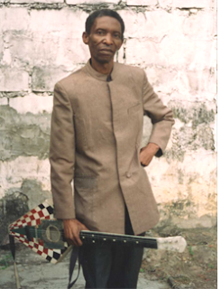
Mwamba Dechaud, who was actually Dr. Nico's brother as well as composer of "Africa Mokili Mobimba." Both brothers were great guitarists.
"Africa!" can be listened to here.
Here is a contemporary version of the song by what appears to be Americans who specialize in mixing Afrobeat, Soukous, and other African and African diasporic genres of music. Their version of the song is actually quite close to the original for the first 4 minutes before shifting to a more contemporary soukous groove. They get brownie points for singing the song in Lingala, too. "Balingi babina miziki y Afrika!"
Here is a version from 1972 that is shorter and features Tabu Ley Rochereau.
Dr. Nico, who played guitar on the original recording, also recorded another great version of the song in the future. Listen to it here. Dr. Nico is great on guitar as usual, playing smooth, ethereal solos with little distortion, a feature I've come to love about Congolese music.
This song, by the way, like many Congolese gems, is based on or loosely inspired by Cuban music. "El Que Siembra Su Maiz" apparently influenced the "Africa Mokili Mobimba." Indeed, Grand Kalle et l'African Jazz recorded the Cuban song in the same year as "Africa Mokili Mobimba"and it sounds eerily similar.
Sam Mangwana also recorded a great version of "Africa." Check it out. He also performed the song live with Tabu Ley Rochereau in 1975 for posterity to enjoy.

