Be a Three

Soliel-Robert H. Knapp, MD

October 14, 2022

All day today, Friday, October 14, 2022, be three in one. Think pink, feel pink and act pink. Be a pink, equilateral triangle, wherein you anchor and express pure Third Ray pink love in the Tenth Temple on Earth, within and without.
Two days ago, we were a number l (one). The next day we became a number ll (two) that is symbolized by a V that has two straight lines joined at their bases. Throughout this 3rd day, see a horizontal line that connects the top two points of the V and forms an equilateral triangle that points downward and glows with the Third Ray pink light of Personal Love, Feeling and Dedication to a Higher Cause.

Triangulated Team
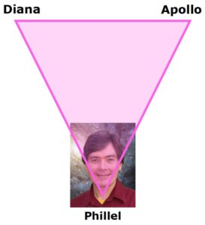
Visualize the bottom apex of this triangle slowly descending and anchoring into your 3rd or throat chakra (as viewed in a vertical, downward representation of the seven major chakras). Speak of, and with, personal love. Love one another and all life forms, here and throughout the solar system.
Especially love and welcome Apollo and Diana into your own Tenth Temple, as well as all their numerous Temple 10 co-workers who have laid down their lives by coming to Earth to help all other light workers.
Also, form a love triangle with K-El-Pa and Lu-See-A, who in Third Ray fashion, love and serve Apollo and Diana. With these four, faith-filled, solar system masters, speak the word and radiate love to Córdoba, Argentina that is the central site of Temple Ten. Be Third Ray love in action.
Even as you love, however, you may be inspired to wield the sword of truth, to speak words of truth to separate the wheat from the chaff, the good from the evil; within and without. Implant both tender and tough love in your mind, body and soul; and bring both forth in your speech and other actions as the situation requires.

Love Southern South America
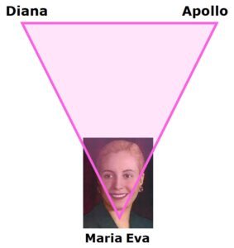
To focus on, and work with, the ongoing re-opening and re-birthing of the Temple of Deca (the Tenth Temple) in central Argentina and the surrounding area, picture a pink triangle descending from the etheric realms down into the seventh or highest astral plane above Cordoba. Therein is Eva Perón whose name Eva has 3 letters, and a V in its center.
Radiate pink love to Eva, who when she was on Earth demonstrated pure personal love in caring for the poor, downtrodden, sick and disenfranchised. See her filled with even greater love and devotion, with still more dedication to Mother Mary and the Second Coming program. See her feeling more empowered to uplift others, as well as herself. See pink light anchoring in her throat that radiates to all in the 7th, 6th and 5th astral planes; and from there down especially to all those women of Argentina, who like her are loving, compassionate and service oriented.
Know that K-El-Pa and Lu-See-A also are joined with you and her in this pouring out of pinkness into every person and kingdom in Argentina and its surrounding five countries.

One Man & One Woman
Who is the one lady in your life that most could benefit from your personal love projections? Who is the one man who likewise needs to be pinked? Whoever or wherever they are, see them transfigured by a descending pink triangle, whose bottom apex is positioned in their throat, and then descends to their heart chakra and physical heart.

Battle the Blow Back
As you re-birth new Third Ray love within you and others, be aware that there probably will be "blowback" in response to your new projections and demonstration. Yes, thankfully, some people and light workers will love you even more. But many will resist, rebel and react negatively.
Be sure to protect yourself. These negative feelings projected to you may seem to creep up on you from out of nowhere, leading you to feel depressed, unloved, filled with self-pity, angry, wanting to retaliate, etc. Or you may have a dream, get a phone call or receive email from someone who treats you badly. Remember, everyone on Earth is self-deceived to some degree. Those deceptions get exposed and expressed with the influx of Third Ray pink light. Misuse and abuse of the Third Ray (selfishness) is how a segment of mankind got trapped in animal bodies in the first place, eons ago.
Let go of your hurts, your desire to do unto others what they are now doing unto you. At the same or another time, however, make it clear that you are not going to put up with anyone's nonsense. Speak the word -- wield the sword. Always do your best to find and express the right balance between tender and tough love in all your personal relationships.
God loves you and so do I. Think Pink; Feel Pink; and Be Pink Love in action!

