Be in Heaven on Earth

Soliel-Robert H. Knapp, MD, ⊕

October 12, 2022

Today, Wednesday, October 12, 2022, we begin the last seven days of our three-week focus on re-vitalizing, re-anchoring and re-birthing the Tenth Temple on Earth, within and without.
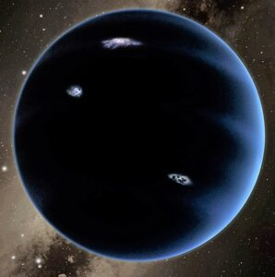
In the first week, we focused on the superconscious, I Am Self, light-body level; and connected with Apollo and Diana, co-leaders of Planet Ten or Deca (see image to left), and with K-El-Pa and Lu-See-A from Vulcan who assist them, with K-El-Pa piloting Apollo's ship #257.
In the second week, we concentrated on the subconscious/astral body aspect; and had soul recall of our past lives and earlier feelings from this life. We connected with Sol-O-Man/Mary as our older sister; María Eva Duarte de Perón now in the seventh astral plane; and astral and physical Amerindians connected with Córboda, Argentina that is the site of the Tenth Temple, power center or vortex of sacred light on Earth.
This week, our goal is to anchor Planet X (10) consciously and physically on Earth, in and through our physical actions. What we have affirmed, seen and felt now will manifest. We will be the Second, Fifth and Seven Rays in combined action.

Be One
In your morning quiet time this first day, link and become one with your I Am Self and light body. Surround and protect yourself inside a 10-foot-in-diameter Christ column of light that encases you in spiritual power and love.
Affirm: I Am one in the One; I Am one with Planet 10; I Am a "10" in all that I think, feel, speak and do.
Unite also with Phillel and me here at Hierarchal/I Am Nation/Sun Temple Headquarters in Pioneer, TN. Each Wednesday, he and I begin our seven-day spiritual week at our 3 PM Hierarchal Board Meditation (HBM). This is when we typically receive new spiritual guidance, directives, images and ideas about how to do the will of Spirit; about how we are to move forward during the rest of the week.
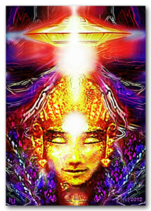
Picture coming down from the etheric and celestial realms a straight, vertical line that forms a number l (one), which is without the usual downward slash at the top of the number 1, nor does it have a horizontal line at its base. Rather it is a single straight line or pole that comes down from above in the three etheric realms, passes through the seven astral planes, and anchors into the physical plane: from your light body (superconscious), through your astral body (subconscious), into the brain of your physical body (conscious). This straight-line anchors at its base into the top center region of your head, which is called its vertex.
(Image to right is by Hartmut Jager of Australia, symbolically showing the hieronic spacebeam assistance of space visitors from Planet X/10.)
Affirm, experience and know: As above, so below; as in heaven, so in the astral planes and on Earth. Affirm and have full faith that the Father, the Mother and You as the Son-Daughter are one. So it is.

Coaxial Core Cable
As you keep focusing on this number one (l) that is now implanted in your brain, visualize the l become bigger in diameter, going from a slim line to a one-to-two-inch-thick-wire or cable. This thick cable comes down from etheric spacecraft, such as Apollo's ship #257 -- he is in coordination with and under the orders of Sananda/Jesus aboard his ship #10.
The Planet 10 space visitors hieronically transmit their signals down through the thick wire/cable to you. Via it, send your thoughts to them. Thus, it is a two-way or a Christ coaxial cable. You and they are one. Planet X and you on Earth are one. As the first of three planets that are fully fourth dimensional or higher, Planet 10 or Deca symbolizes "heaven" that you now re-birth on Earth.
From the bottom of the cable now appear thousands of tiny wires, one of which inserts into each one of the 144,000 centers in your two cerebral hemispheres at the top half of your brain. These wires form a cap over your head like a yarmulke (skullcap), helmet or dome. Feel it from about the top of your eyes and ears upward.

Ask & Receive
Ask Spirit to show you the unique way(s) that you are to proceed in re-birthing your own Tenth Temple, and then in re-generating the Tenth Temple in and around Córdoba in central Argentina, whose forcefield goes out hundreds of miles in all directions, encompassing the southern half of South America.
The answer(s) will come down through the coaxial cable. If you receive nothing at first or do not understand such input, send your questions back up the coaxial cable. Then, with full faith and confidence, wait peacefully and expectedly in your meditation.
As in all such conversations, however, remember that sometimes it is best to be quiet and to savor the Silence. For the time being, no answer may be your answer: In other words, be at peace. Your specific answer may come later as you take a walk or a nap, work in your garden, read spiritual literature, have a sudden flash of insight ("aha" moment), or in a dream that night.

Be a Blue Brain
As the bottom of the l and its 144,000 wires become still more firmly implanted in your two cerebral hemispheres, hence also your subconscious and conscious minds, become aware that your whole crown chakra and cerebrum becomes imbued with a vivid, sparkling, vibrant blue light. (See image below.)

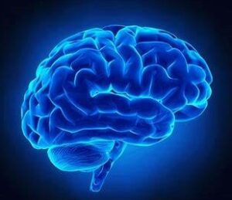

In the 12-Powers approach, faith is royal blue, will is sky blue, and power is blue-green (aqua). Affirm: I have the faith of my I Am Self; Thy will be done with Your power. As a re-born “10,” I talk the talk and walk the walk.
With First Ray faith, will and power, realize that you can move mountains, that you can re-invigorate, re-vitalize and re-birth the Tenth Temple in you and in Córdoba, Argentina and its surrounding five nations. See what shade of blue comes to you. Be in this holy hue. After coming out of meditation, begin your God-given specific way to re-birth the Tenth Temple on Earth.
Thank You, Spirit, and all agents of Spirit. Om. Amen. It is done. We are One. Temple 10 is implanted and in 6 more days will be re-born on Earth!
