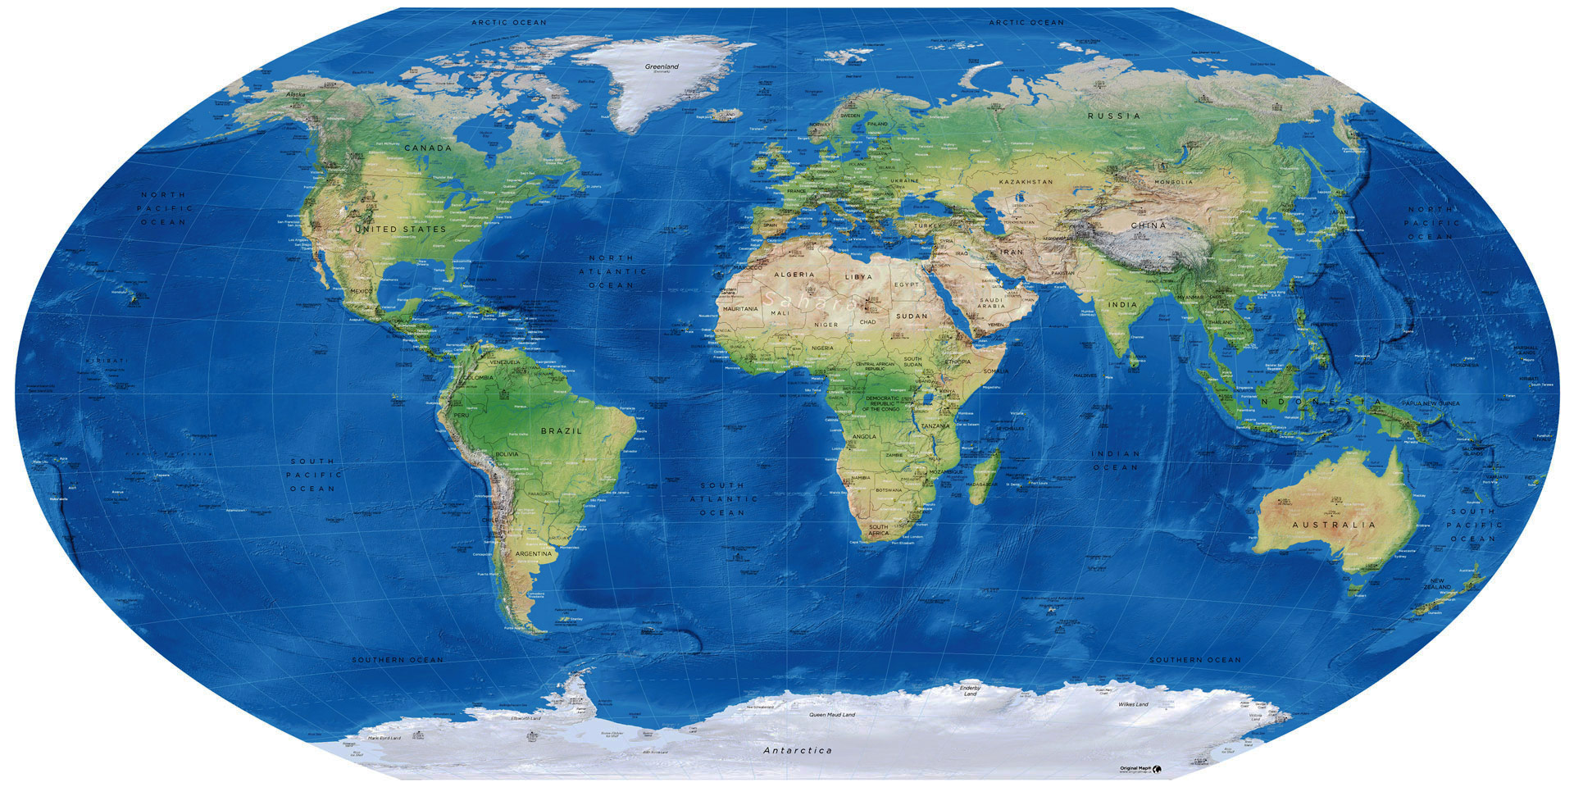
13 TEMPLES or POWER CENTERS
MARS
Sun Temple: Pioneer, TN, USA
MERCURY
12th PLANET
(VULCAN)
JUPITER
NEPTUNE
11th PLANET
10th PLANET
URANUS
SUN
EARTH
PLUTO
VENUS
SATURN
1. Temple of Neptune: Olkhon Island, Siberia 7. Earth Temple: Central Long Island, NY, USA
2. Temple of Mercury: northeast India, Nepal 8. Temple of Jupiter: Xian, China
3.Temple of Venus: Grand Teton Mountains, USA 9. Temple of Pluto: Paris, France
4. Temple of Mars: Jerusalem, Israel 10th Invisible Planet Temple: Southern Argentina
5. Temple of Uranus: Manaus, Brazil 11th Invisible Planet Temple: Mt. Kilimanjaro, Africa
6. Temple of Saturn: Mt. Denali, Alaska 12th Invisible Planet Temple (Vulcan): South Vietnam
© Mark Age Inc./Healing Haven 2022 – Web: https://healinghavenhilarion.com – Email: solielrobert@gmail.com

