Three Lakes in Tanzania
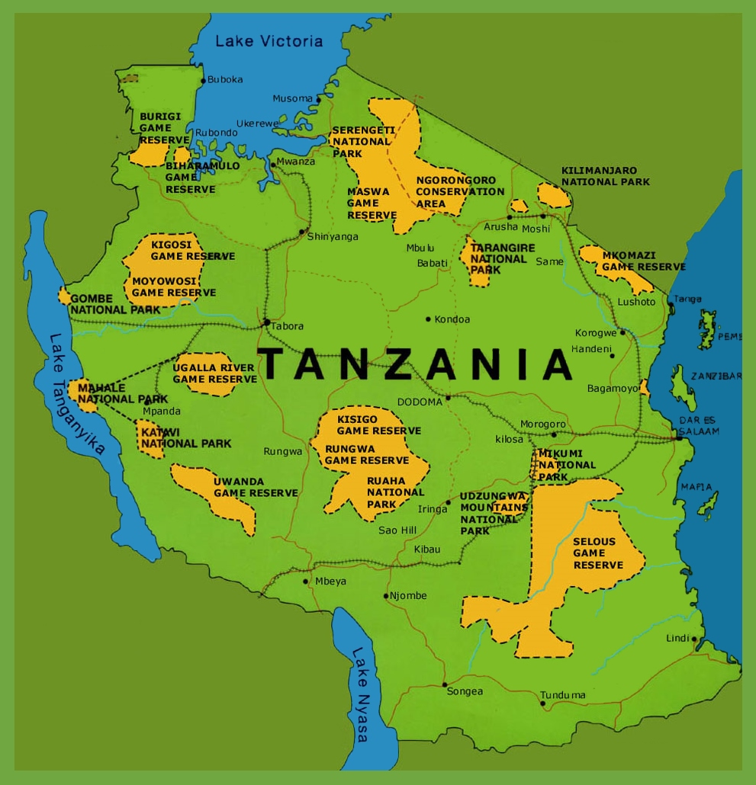
Victoria, Tanganyika & Nyasa

