**Map of Rwanda**

**Lake Kivu**

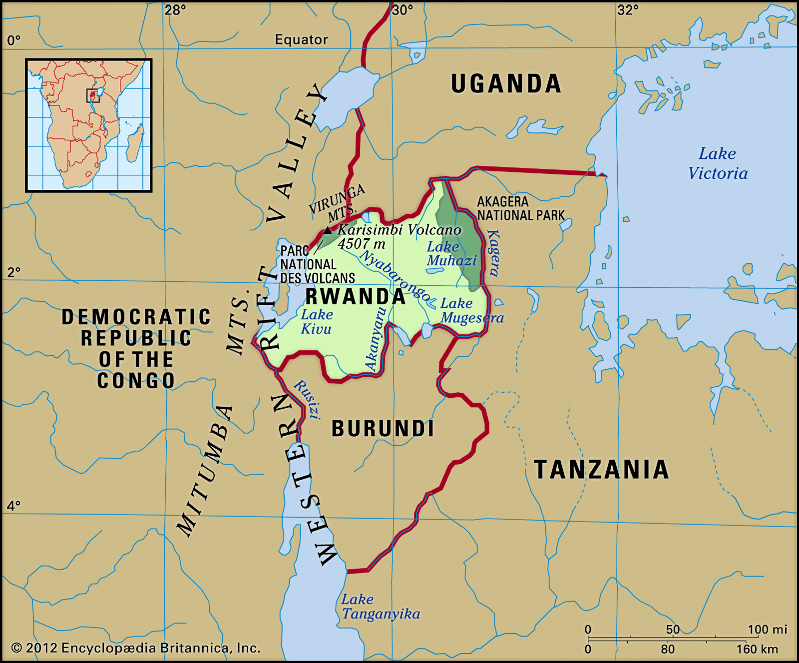

**Kibelo**