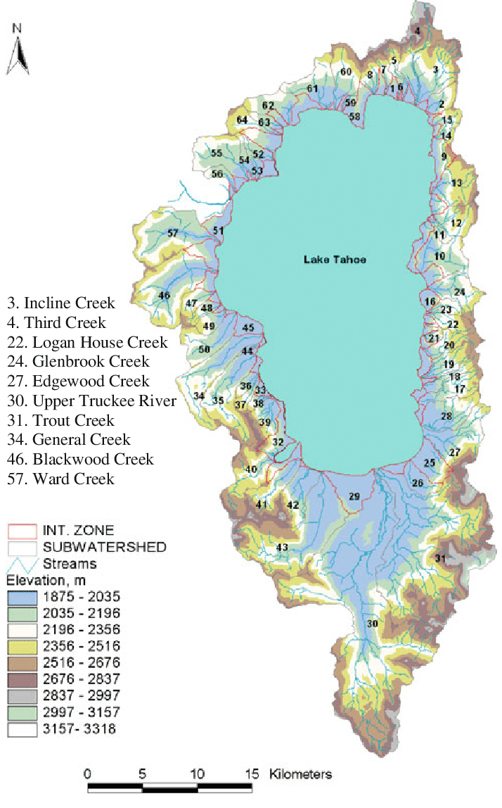
64 Tributaries of Lake Tahoe

