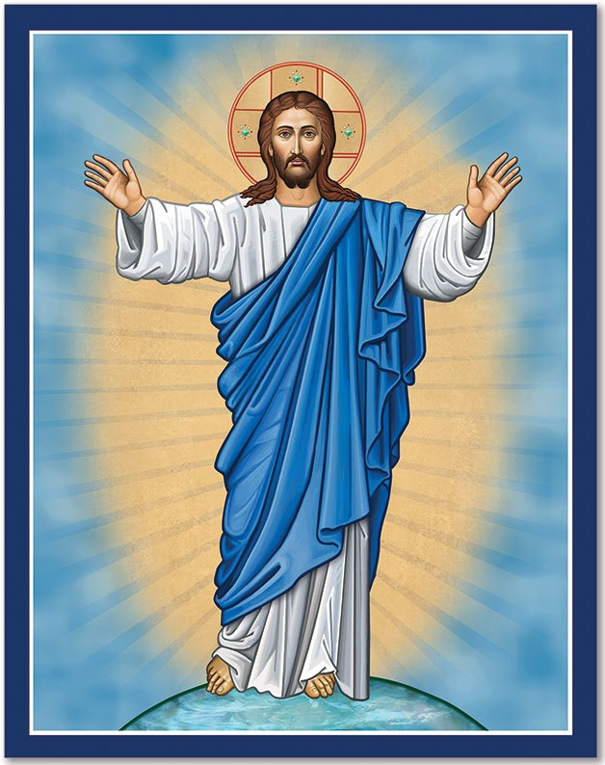**By Your Faith, You Are Healed**