**Supper at Emmaus**

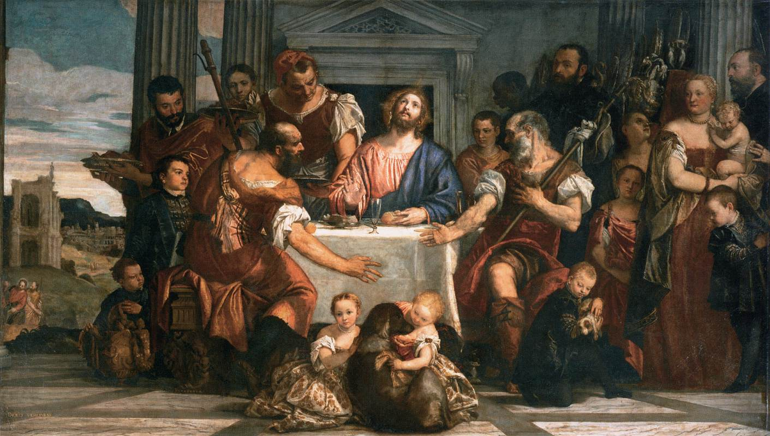**Paolo Veronese**